**PIZZA SALES REPORT**

**-MOHANISH GUPTA**

**PROBLEM STATEMENT**

**KPI’s REQUIREMENT**

We need to analyse key indicators for our pizza sales data to gain insights into our business performance. Specifically, we want to calculate the following metrics:

1. **Total Revenue**: The sum of the total price of all pizza orders.
2. **Average Order Value**: The average amount spent per order, calculated by dividing the total revenue by the total number of orders.
3. **Total Pizzas Sold**: The sum of the quantities of all pizzas sold.
4. **Total Orders**: The total number of orders placed.
5. **Average Pizzas Per Order**: The average number of pizzas sold per order, calculated by dividing the total number of pizzas sold by the total number of orders.

**Total Revenue**



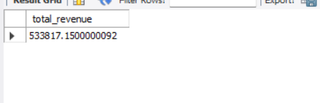

**Average Order Value**





**Total Pizzas Sold**:

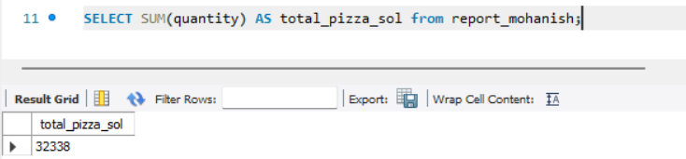

**Total Orders:**

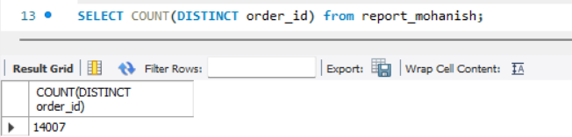

**Average Pizzas Per Order:**

**PROBLEM STATEMENT**

**CHARTS REQUIREMENT**

**To gain insights and understand key trends in pizza sales data, the following charts are required:**

1. **Daily Trend for Total Orders**
   * **Create a bar chart that displays the daily trend of total orders over a specific time period.**
   * **This chart will help identify any patterns or fluctuations in order volumes on a daily basis.**
2. **Monthly Trend for Total Orders**
   * **Create a line chart that illustrates the hourly trend of total orders throughout the day.**
   * **This chart will allow identification of peak hours or periods of high order activity.**
3. **Percentage of Sales by Pizza Category**
   * **Create a pie chart that shows the distribution of sales across different pizza categories.**
   * **This chart will provide insights into the popularity of various pizza categories and their contribution to overall sales.**

**Daily Trend for Total Orders:**

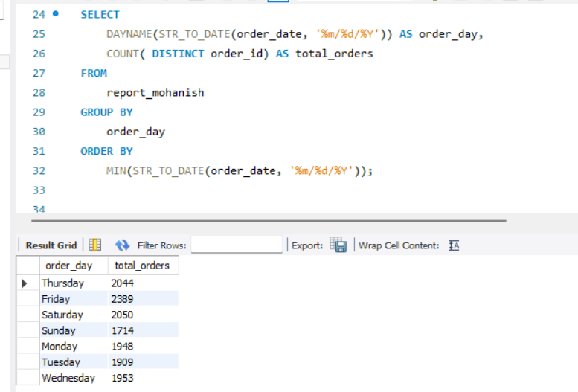

**Monthly Trend for Total Orders:**

**Percentage of Sales by Pizza Category**

**Percentage of Sales by Pizza Size  
Generate a pie chart that represents the percentage of sales attributed to different pizza sizes. This chart will help us understand customer preferences for pizza sizes and their impact on sales.**

**Total Pizzas Sold by Pizza Category  
Create a funnel chart that presents the total number of pizzas sold for each pizza category. This chart will allow us to compare the sales performance of different pizza categories.**

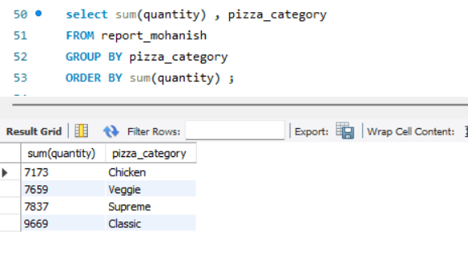

**Top 5 Best Sellers by Revenue, Total Quantity and Total Orders  
Create a bar chart highlighting the top 5 best-selling pizzas based on the Revenue, Total Quantity, and Total Orders. This chart will help us identify the most popular pizza options.**

**Bottom 5 Best Sellers by Revenue, Total Quantity and Total Orders  
Create a bar chart showcasing the bottom 5 worst-selling pizzas based on the Revenue, Total Quantity, and Total Orders. This chart will enable us to identify underperforming or less popular pizza options.**

